**CYBER GEEKS INTELLISCOUT VER.2**



**Fig 1: *Block Diagram of Surveillance Robot***



**Fig 2: Manual Automatic Operation**



**Fig 3: Connections of *Surveillance Robo***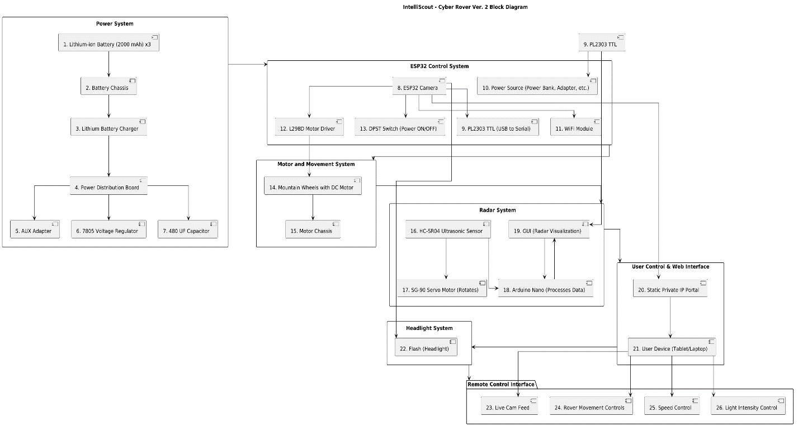

**Fig 4: Complete WorkFlow of IntelliScout Ver.2**

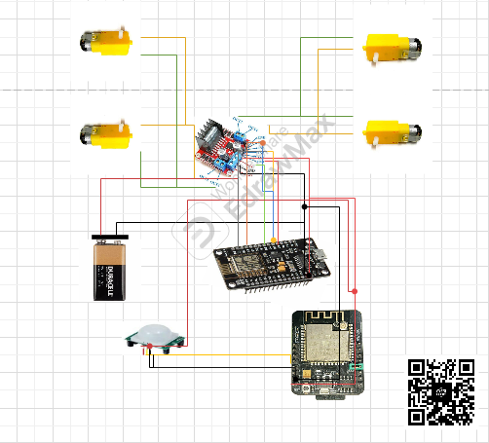

**Fig 4: Major Connections of ‘Spybot’**

|  |
| --- |
| ***C:\Users\Admin\Downloads\Untitled.png*** |

**IntelliScout V2: High-Precision Autonomous Spybot with Live Camera and Radar for Efficient Surveillance**

**(Dhruv Dhayal & Pratham Aggarwal)**

**Team : CYBER GEEKS**